December 7th, 2018

Greetings Dr. Roysam,

We want to thank you again for approving our Makerspace and senior design project, Knuckles, the assistive robotic arm to be exhibited at the 2019 ECEDHA Conference in Tucson, Arizona.

We have finished constructing the robot arm and are able to control the motors using Arduino and Rviz. We still need to work on tuning the motion of motors. We are currently installing the hardware on the physical arm such as the camera mount and the tactile pads on the gripper. During the winter break, we will be working on developing a GUI, improving the April Tags detection and implementing a communication system between the Intel Speech Development Kit and Raspberry Pi3+ to start processing speech to text. In the Spring semester, we will focus on connecting all the modules of the project to accomplish an automated and autonomous system.

We are still discussing some current needs such as the Intel Voice Enabling Development Kit and a PC. We are seeking company sponsorship to lower the overall cost to the department.

Overall, we are on track and are confident on meeting our deliverables.

We are extremely grateful for your continued support of our research. If you have any questions or concerns, please feel free to contact us.

Sincerely,

Andrew Blanchard, Matthew van Zuilekom, Rym Benchaabane, Paola Hernandez

# 

# Knuckles, Assistive Robotic Arm

# Sponsored by Makerspace

# Fall 2018

# Final Technical Report

# Andrew Blanchard, Matthew van Zuilekom, Paola Hernandez, Rym Benchaabane

# 

# 

# 

**Abstract**

Knuckles is an assistive robotic arm that will hand the user requested objects and tools through voice commands. Its purpose is to help increase the user’s productivity and decrease the risk of dexterity accidents. This project combines robotic motion and voice/object detection. Knuckles is a five axis robot with a two finger gripper. The arm will be processing a voice input from the Intel Speech Development Microphone, a visual input from the Intel RealSense Camera and a motion input from the Arduino Mega 2560. All the data will be interpreted by the Robot Operating System (ROS) installed on a computer. As for our team’s current progress, the arm is 95% built. We still need to install the gripper motor, the microphone and camera on the arm. We can control the arm using a simulation in Rviz. The robot can also detect AprilTags in Rviz, and can provide the tag distance and location in the received image. Our next step is to have the arm follow the AprilTag, which will lead to Knuckles’ ability to grab an object. This project is costly with a total budget of $1800, this is why we would like to thank our sponsor, Dr. Roysam.

**Purpose and Need**

Knuckles is an assistive robotic arm that will hand the user requested objects and tools through voice command. It will serve as a convenient assistant that will increase the user’s productivity and decrease the risk of dexterity incidents. The problem is that multitasking causes a lack of focus on a task which results to a waste time, money, and can also lead to serious injury. What is needed is a solution that allows the user to continue with their task without distractions, and can assist the user as needed. The extra hand will allow one to focus on the work without having to get up and grab another tool, which saves one time and effort in completing the current task.

**Overview Diagram and Background**

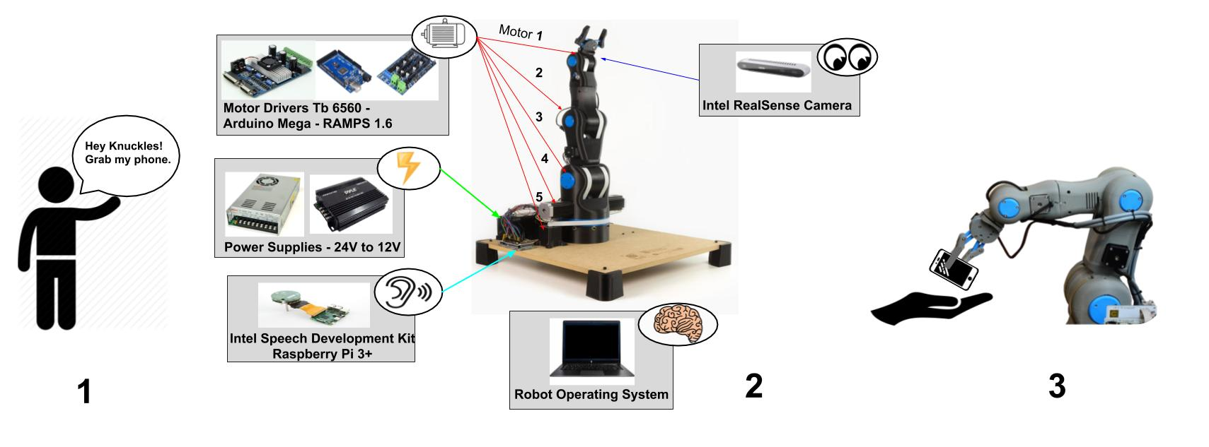

**Figure 1. Overview diagram of Knuckles functionalities**

Knuckles will be able to respond to voice commands and retrieve requested objects for the user. To accomplish this, we will connect a microphone to a RaspBerry Pi3+ which will start listening for a voice command once the user has said “Hey, Knuckles!” Voice commands will be converted to text using the Amazon Alexa Voice Service, to be interpreted by ROS on a main computer, which the RaspBerry Pi3+ is also connected. From there, the main computer will connect to an Arduino MEGA & RAMPS 1.4 combination, which is connected to the motors used to control the arm. An Intel RealSense camera will be attached to the gripper of the robot arm, which will be used to locate the requested object. An AprilTag will on each requestable object, which is what the camera will be looking for.

In today’s society, people are rushed and tend to multitask. According to research from the scientific journal, *Current Biology[1]*, shifting focus and attempting to multitask reduces productivity by around 40%. *SMF Mutual Insurance* adds that multitasking can lead to dexterity incidents while performing hands-on work.[2]

The problem is that multitasking causes a lack of focus on a task which results to a waste time, money, and can also lead to serious injury. What is needed is a solution that allows the user to continue with their task without distractions, and can assist the user as needed. The extra hand will allow one to focus on the work without having to get up and grab another tool, which saves one time and effort in completing the current task. Figure 1 represents Knuckles’ ability to respond to voice commands and hand the requested object to the user.

**User Analysis**

Our device will be used by users doing hands-on work who are unable to step away from their work, or users with disabilities. It can be operated by most in the general public, as the method to control it will simply be voice commands, which most people are capable of. The user will need minimal expertise, as they will need to know to say “Hey, Knuckles!” to have the arm start listening for voice commands, and they will need to know how to structure the command.

**Target Objectives and Goal Analysis**

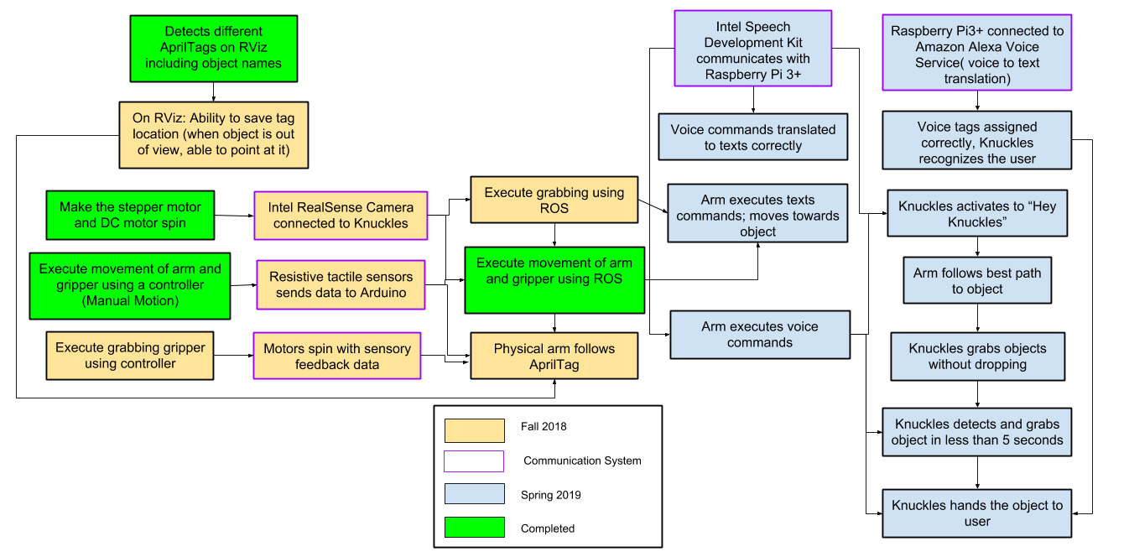

**Figure 2. The testing and goals diagram**

**Summary of Activities**

|  |  |  |  |  |
| --- | --- | --- | --- | --- |
| **Goal Status** | **Goal Description** | **Goal Modifications** | **Test Plan** | **Issues** |
| **Completed** | This allows us to confirm the arm is moving correctly and free, before applying software to it. The mechanical properties of Knuckles are divided into two components, the arm and the gripper. | None | **Test the mobility of the robot:**  Verify the arm and gripper motion with a controller. This arm uses seven motors: six to control the movement of the arm, and one to control the gripper. The controller will be able to control each of these motors individually by changing the polarity and magnitude of the voltage across each of the motors. Two of the six motors used to control the arm will control the same movement at the base of the gripper, so the controller will have to control those two motors at the same time as well | We had a significant delay ordering the necessary parts as we were doing it through Makerspace, which caused the construction of the arm to be delayed. |
| **Completed** | The goal was to have the arm properly communicating with ROS, and be able to control the entire arm using this software.  We are connecting the arm’s joints with a total of 6 stepper motors (2 for the base). These motors will be processed by ROS and controlled by Arduino. The Arduino has a add-on motor shield RAMPS1.4V. The TB6560 is the motor driver that is going to be directly wired to the motors and RAMPS1.4V. The RAMPS1.4V is powered by a 24V to 12V converter and this converter is connected to a 24V power supply. We have a breadboard as a center of power connections. | None | **Test robot connection to ROS:**  Request the robot to position itself in straight up, straight out,  and in reaching motions. The test will be successful if these basic movements are shown in both the simulation and the physical arm. | None |
| **Completed** | This is a major part of the project. Rviz is able to visualize as many tags as we can fit in the camera view, and is able to remember the object position once it has left the camera view. It provides the object translation/location in the camera view, the orientation of the object, and the object distance from the camera. The visual processing for Knuckles is handled using RViz and AprilTags. Knuckles will utilize the Intel RealSense Depth Camera D435. | We decided to use AprilTags instead to simplify our project. AprilTags allows our camera to easily locate an object in the room, and provides the position of the object in the camera view and also allows us to calculate the distance away from the object. RViz is our 3D visualization application for ROS that will work with the Intel Camera. | **Test object recognition with AprilTags:**  Validate the simulation can recognize multiple objects at the same time. We will verify that different frame will surround the different visible objects without naming them yet. | We initially planned to use OpenCV & TensorFlow for this. However, due to complications using a non-ROS program and trying to have it communicate with ROS |
| **Completed** | AprilTags are able to accomplish this much more easily, without having to create a point cloud of the entire environment. We can simply find the tag position in the environment. Instead, Rviz will map the specific location of the AprilTags, rather than mapping the entire environment. | None | **Test the ability of the robot to map the environment:**  Compare map data representation to that of the workspace of the robot. Through this we we test the object localization, and recognize the various objects around the arm. | None |
| **Incomplete** | The robot is able to associate AprilTag to an object name and detect it.  The gripper should be able to grab the object. | Usage of AprilTag instead of actual objects. | **Test the object search function:**  Use text recognition to have the robot point at objects. This will serve as the initial point where the robot responds to commands. The robot should be able to properly respond to 10 objects.  **Test the object retrieval function:**  Use text recognition to retrieve an object. | None |
| **In progress** | Implement a communication system with Intel Speech Development Kit, Raspberry Pi 3+ and ROS to make Knuckles process voice commands. | None | **Tests the voice recognition:**  Compare voice commands to the text in the ROS terminal.  **Test the user search function:**  Upon voice request, have the robot find the user. | None |
| **Incomplete** | The gripper should be able to grab the object and return the object | None | **Test the return function:**  Have the robot drop the object as close to the user as possible.  **Test the gripper with the return:**  Have the robot wait until the user is within range and pulls on the object. | None |
| **Incomplete**. | Make the robot react and complete task 0.5 times as fast a human. | None | **Test the timing of the entire process:** Our goal is for the arm to be able to locate the correct object within 5 seconds, and then grab within 3 seconds. | None |
| **In progress** | Create a GUI for the user to interact with Knuckles | None | **Test the responsiveness and communication between GUI and Knuckles:**  Press a home button to have Knuckles stand straight in an initial position. | None |

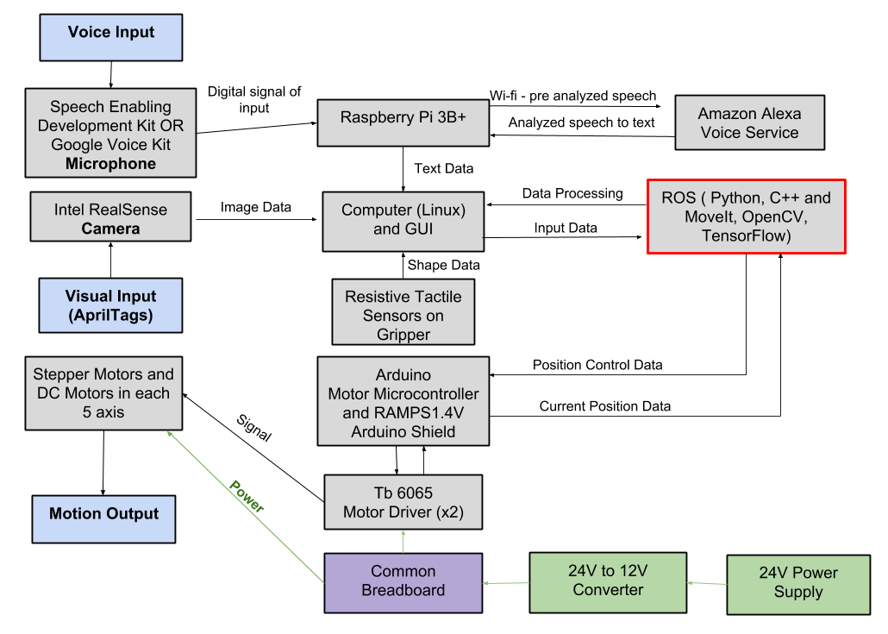

**Figure 3. Design diagram and interactions between parts of the project**

Initially, we were planning to use a 3D object detection program using the depth camera and a pointcloud. However, with the inclusion of AprilTags, we can simply use the tags to get the object position in the received image, and also calculate the distance of the gripper to the tag, which was the purpose of the 3D object detection program. Thus, for the Spring semester deliverables, we will completely finish building the robot arm and fix any movement complications, such as a pulley slipping on a motor shaft. The arm will be able to use AprilTags to receive and deliver an object to the user. We have decided to use an Intel Speech Enabling Developer Kit as our omni-directional microphone, which will be purchased over the winter break.

Our main design constraint is the time allotted to develop a gripper that’s capable of grabbing a larger range of objects. In addition, our motors can become overheated if we are testing the arm for too long of a time interval. We will continue trying to reduce the heat supplied by the motors, but for now this is a constraint we must accommodate for.

**Budget**

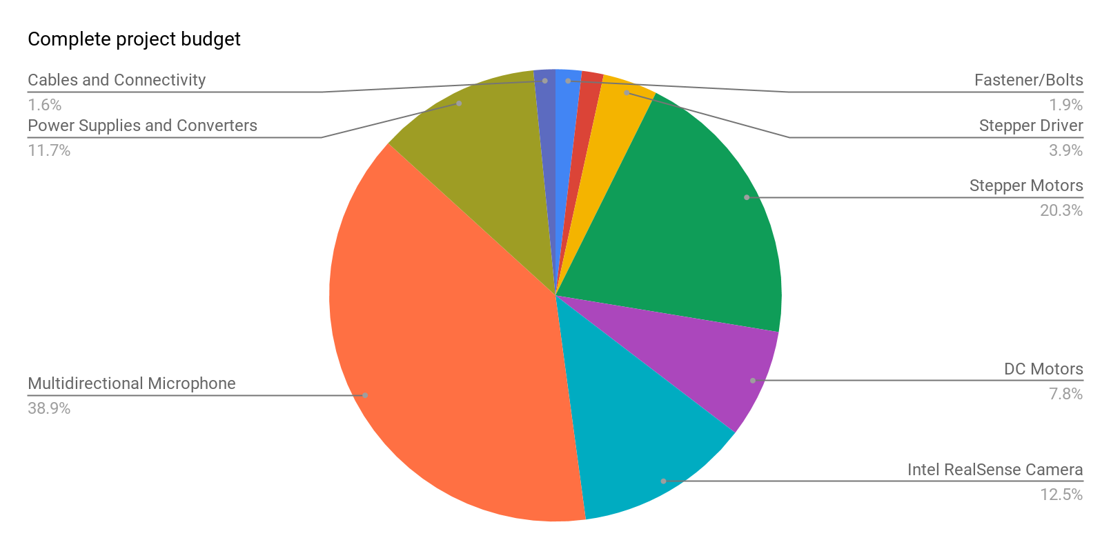

**Figure 4: Graphical representation of budget**

We would like to thank our sponsors for making this project possible. We are still discussing some current needs such as the Intel Voice Enabling Development Kit and a PC. These two components represent almost 40% of the budget. Therefore, we are going to seek company sponsorship to lower the overall cost to the department. Overall, our total budget is $1,800. Any project optimization and improvements are mainly software based rather than hardware. It will require more man hours.

**Project Summary**

To summarize, the physical robot arm is constructed and we are currently testing the motors motions. We need to work on tuning the motors to have smoother motions. For now, the user will be able to use a simulation in RViz to control the robot through text commands. By the end of the Spring semester, the object detection and voice recognition of the project will be completed, and the user will be able to give voice commands to request objects from Knuckles. We will accomplish our target objective by following a modular test plan, allowing us to develop the hardware and software in tandem. We are on track to complete our project by the end of the Spring semester.

1. Gross, Michael. “Chronic stress means we’re always on the hunt”. Current Bioligy, https://www.cell.com/current-biology/fulltext/S0960-9822(14)00489-8
2. Boblard, Lionell. “Injured Workers.” *SFM Mutual Insurance*, [www.sfmic.com/injured-workers/](http://www.sfmic.com/injured-workers/).